Nakayoshi Gakko
Arts and Crafts Committee

Classes: Kirin
Pick up Board

Project: Geta

Material: Wood

Equipment: Jig Saw, Sander and wood glue

Qty. Needed: 18 (one pair per student)

Instructions: Trace the pattern onto the wood. Cut out the getas with a saw and sand the edges. Glue the bottom ha with wood glue. Use clamps or heavy object while glue dries. Drill holes for straps.
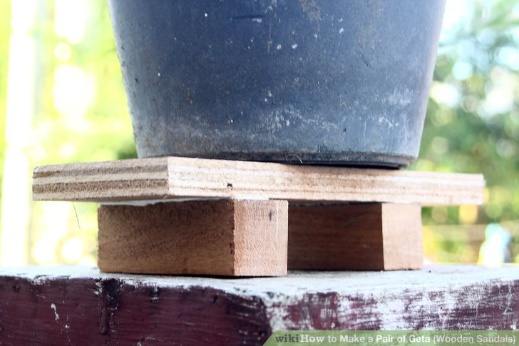

Date Due: Bring completed project with you on Maintenance I Day prior to the start of session. Please return the sample and any unused supplies.

Thank you in advance for your help! ☺

